
MR. V. SENTHIL
NO: 1/192, NEW NO 1/12 VANDAVASI ROAD, SOTHUPAKKAM, MELMARUVATHUR POST,
CHEYYUR TALUK, KANCHIPURAM -603319.
Subject: Appointment for post of STRUCTURAL DESIGNER & SITE INCHARGE with GLOBAL WATER PROJECTS PVT LTD.
- Commencement of employment
Your employment will be effective, as of 29/11/2020
- Job title
Your job title will be STRUCTURAL DESIGNER & SITE INCHARGE, and you will report
to Mrs. Sujatha, GENERAL MANAGER.
- Salary
Your salary and other benefits will be as set out in schedule 1, here to.
- Place of posting
You will be posted at CHENNAI, TAMILNADU. You may however be required to work at any place of business which the Company has, or may later acquire.
- Hours of Work
The normal working Time are 9.30 through 18.00. You will be required to work for such hours as necessary for the proper discharge of your duties to the company. And you are expected to work not less than 8 HOURS each day, and if necessary for additional hours depending on your responsibilities.
- Leave/Holidays

  - you are entitled to casual leave of 4 SUNDAYS.
  - You are entitled to SICK LEAVE 1 WORKING DAYS of paid sick leave.


Head Office : $24. street. 1st Road, Cncnnai COO 076 CIN No. . U29100TN20!6PTC110435 P •91 • 84699 18521 IE •n


Global Water Projects Pvt Ltd
Water the Source of life... and our success...
An ISO 9001: 2015 certified company
6.3 The company shall notify a list of declared holidays in the beginning of each year.
- Nature of duties
You will perform to the best of your ability all the duties as are inherent in your post and such additional duties as the company may call upon you to perform, from time to time. Your specific duties are set out in Schedule Il here to.
- Company property
You will always maintain in good condition Company property, which may be entrusted to you for official use during the course of your employment and shall return all such property to the Company prior to relinquishment of your charge, failing which the cost of the same will be recovered from you by the
Company.
9.Borrowing / accepting gifts
You will not borrow or accept any money, gift, reward or compensation for your personal gains from or otherwise place yourself under pecuniary

obligation to any person/client with whom you may be having official dealings.
- Termination / Resignation
  - Your appointment can be terminated by the Company, without any reason, by giving One Month prior notice from either side. For the purpose of this clause, salary shall mean basic salary.

  - The Company reserves the right to terminate your employment summarily without any notice period or termination payment, if it has reasonable ground to believe you are guilty of misconduct or negligence, or

Head Office : 524. Sunder street 1st Road. vagat -84899 18521

Company.
10.3 On the termination of your employment for whatever reason, you will return to the Company all property; documents and paper, both original and copies thereof, including any samples, literature, contracts, records, lists, drawings, blueprints, letters, notes, data and the like; and confidential Information, in your possession or under your control relating to your employment or to clients" business affairs.

and information only in a duly authorized manner in the interest of the Company. For the purposes of this clause 'Confidential Information ' means information about the Company's business and that of its customers which is not available to the general public and which may be learnt by you in the course for your employment. This includes, but is not limited to, informa n^{et VI}' relating to the organization, its customer lists, employment policies, perso n
Sundcr street, 1st Main Road, Chcnnaj - 076 No P • 84899 10521 IE I w
- Confidential Information
  - During your employment with the Company you will devote your whole time, attention and skill to the best of your ability for its business. You shall not, directly or indirectly, engage or associate yourself with, be connected with, concerned, employed or engaged in any other business or activities or any other post or work part time or pursue any course of study whatsoever, without the prior permission of the Company.
  - You must always maintain the highest degree of confidentiality and
keep as confidential the records, documents and other Confidential Information relating to the business of the Company which may be known to you or confided in you by any means and you will use such records, documents

and information about the Company's products, processes including ideas, concepts, projections, technology, manuals, drawing, designs, specifications, and all papers, resumes, records and other documents containing such Confidential Information.
11.3 At no time, will you remove any Confidential information from the office without permission
11.4 Your duty to safeguard and not disclose confidential information will survive the expiration or termination of this Agreement and/or your employment with the company.
11.5 Breach of the conditions of this clause will render you liable to summary dismissal under clause above in addition to any other remedy the Company may have against you in law.
- Notices
Notices may be given by you to the company at its registered office address. Notices may be given by the company to you at the address intimated by you in the official records.
- Applicability of Company Policy
The Company shall be entitled to make policy declarations from time to time pertaining to matters like leave entitlement, maternity leave, empoyee's benefits, working hours, transfer policies, etc., and may alter the same from timeto time as its sole discretion. All such policy decisions of the company shall be binding on you and shall be binding on you and shall override this Agreement to that extent.
- Governing Law/Jurisdiction

Your employment with the company is subject to Indian laws. All disputes shall be subject to the jurisdiction of CHENNAI HIGH COURT, TAMILNADU only.
- Acceptance of our offer
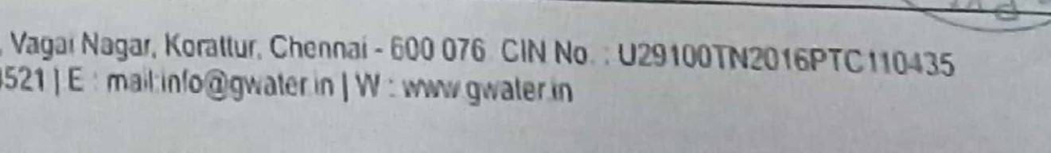
Head : sundcr Street Road, p •91
84899
18521

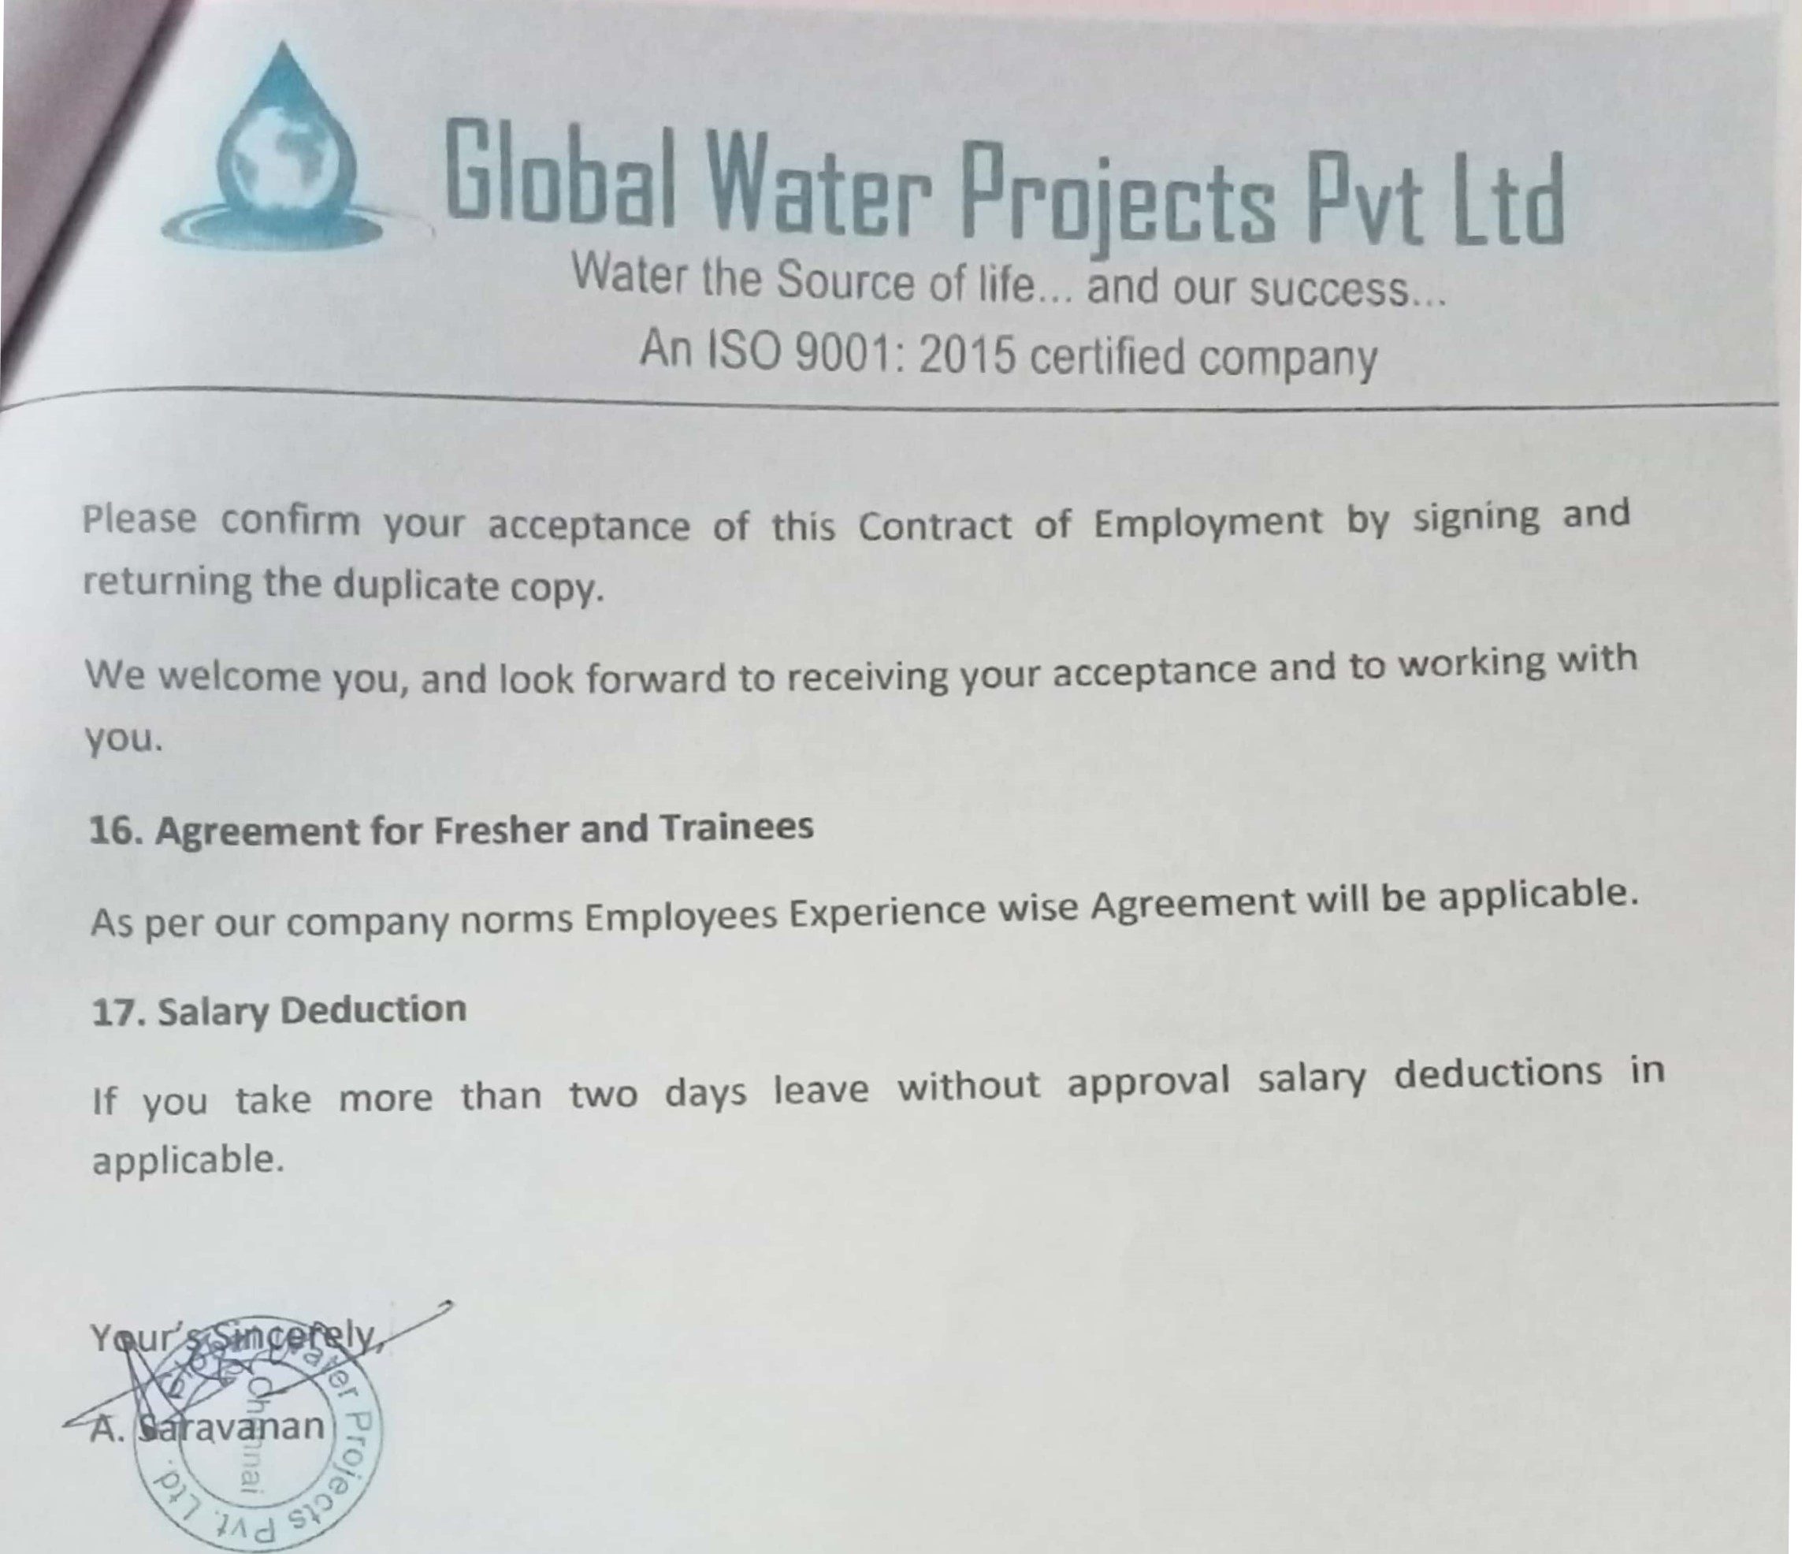
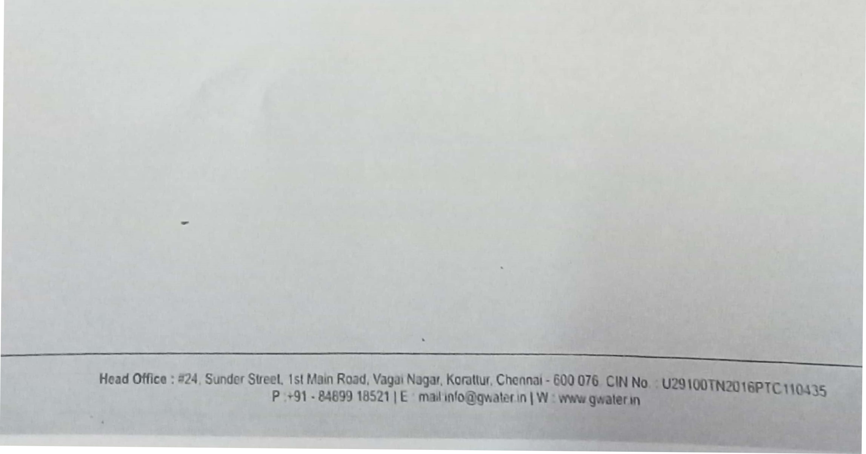
Global Water Projects Pvt Ltd
Water the Source of life. . and our success.
An ISO 9001' 2015 certified company
Schedule I — Compensation Details
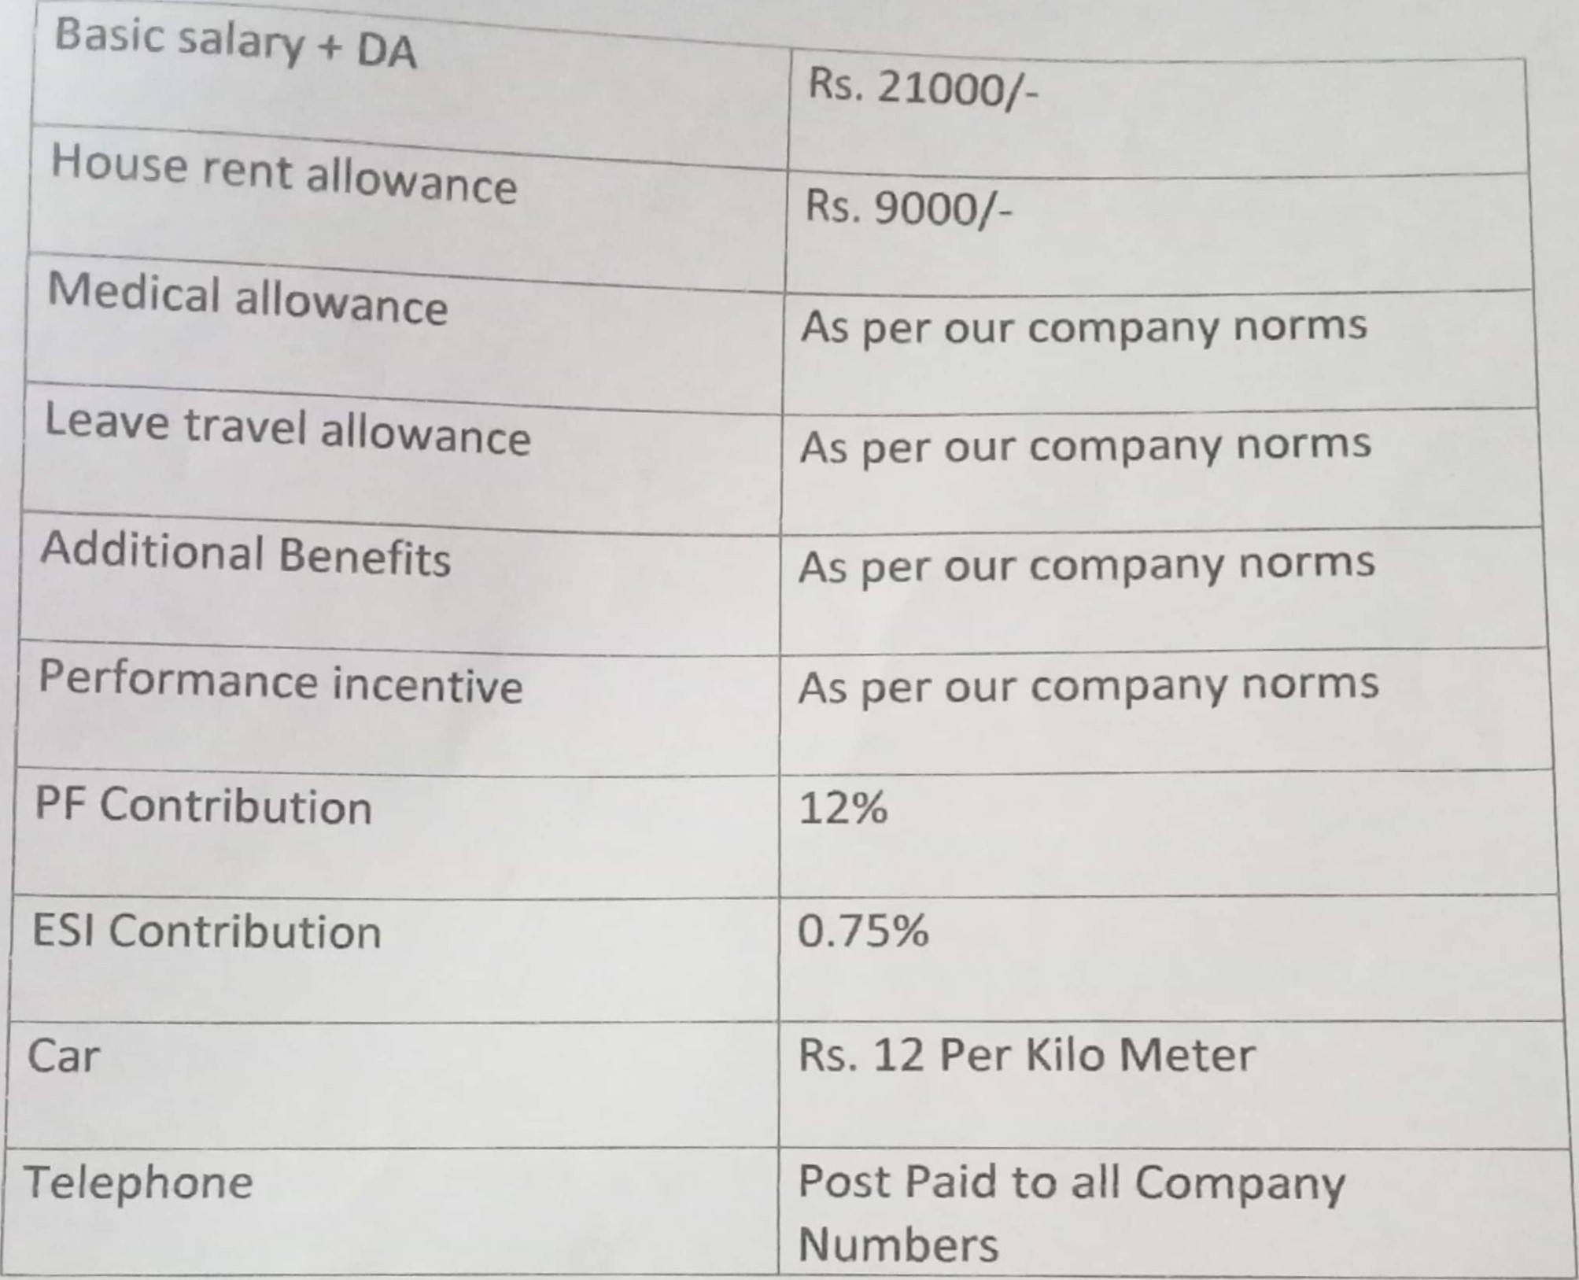
Salary
structure
Note: You will receive salary, and all other benefits forming part of your remuneration package subject to, and after, deduction of tax at source in accordance with applicable law.


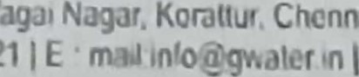
Head Office : Sr,dcr street 1st Road. - too 076 CIN No :
Chennai
P • 18521 | E W

